SDD-630 Activity 3

Monetize Your Application

Background
In this activity, you will identify the key relationships and business strategies for your application idea. First, read the background information from the textbook and the following summary. Then you will create a BMC (Business Model Canvas) as shown in the textbook readings.

What follows is a summary of business strategies for various types of applications. In the first category, the application supports an already successful business. In the second category, you will see applications that are the source of the business income.

- Applications That Support a Business

If you work in an existing and profitable company, the application you create doesn't need to generate its own revenue. Instead, the application merely needs to facilitate and enhance an existing business strategy.

Here are several companies that have nailed the digital transformation with innovative applications. Each of these applications increases company efficiency, helps customers make decisions, improves customer experience, and/or increases orders. For every one of these applications, it can be assumed that the company justified the expense of creating the application with promise of increased revenue.

- McDonald's app – Find closest restaurant, order ahead, skip the line, reward points.
- Walgreens – Refill prescription by scanning barcode, video chat with doctor, medication reminders, check prescription availability in nearby stores.
- Ikea – Show furniture placement in home using augmented reality, place orders.
- L'Oréal – Makeup Genius uses augmented reality to "try on" facial makeup in a virtual mirror.
- Kraft – iFood has recipes, coupons, and shopping lists featuring Kraft products.
- MLB – Allows the user to watch and listen to baseball games, buy merchandise, order tickets, query stats, read news, and follow team standings.
- Any Major Bank – Deposit checks with a phone camera, get account balance, make e-payments, freeze credit cards, receive instant notifications for account activity.

- Revenue Models for Self-Supporting Applications

If an application isn't designed to enhance an existing business, then the developer needs to identify ways for the application to generate revenue on its own. Here are eight common models for generating revenue from application users.

Model | Description | Example | Advantages | Disadvantage
Paid Purchase | Customers pay for the application before using. | Minecraft, WolframAlpha | Simple. Payments handled by application store. | Customers prefer free-to-try.
Paid Subscription | Customers pay a recurring fee to use the application. | Netflix | Simple. 2x more profitable than other models. | Application stores charge 15% fee for auto-renewing subscription initiated within the application.
Freemium | Customers try a free version. Best features available in paid version—either one-time purchase or subscription. | Spotify, Zoom | Customers are likely to try out the application and will pay if the application is good. Popular model. Simple and flexible. | 30% application store fee.  Requires careful balance of premium vs. free features.
Advertising | Free application with periodic interruptions or sponsored display ads. "No ads" version available for a fee. | Facebook, Instagram, YouTube | Free means more customers. Payments handled by Google. | Extremely annoying to users. Only pays well for high-volume usage.
In-application Purchases | Free to use. Users purchase virtual goods to enhance the experience. Popular game model. | Fortnite | Free means more customers. Payments handled by Google. Can be combined with other revenue models. | 30% application store fee for virtual assets. Physical products (Amazon) and services (Uber) are not taxed. See Fortnite vs. Apple lawsuit.
Crowd Funding | Anyone can invest money in your venture. You give something in return, such as company ownership or first access to the product itself. This model is often used for physical products. |  | Money is up-front. Allows for development without as much risk. | Users expect applications to be free or inexpensive, available immediately. Large numbers of backers required.
Sponsorship | A brand places its name on your application. |  | One sponsor pays for the development in exchange for a logo or product endorsement. | Good luck in getting a sponsor unless you are already successful.
Lead Generation | Application provides a guide to products or services. | TripAdvisor
Data Licensing | Sell user data to another company. | LinkedIn, Uber Eats | Steady source of income. | Users feel like they are being exploited.

- Business Model Canvas

The textbook provides a sample BMC, Business Model Canvas, based on "Venyo", a bar and drinks application that is all about enabling users to find bars and order drinks with a discount.
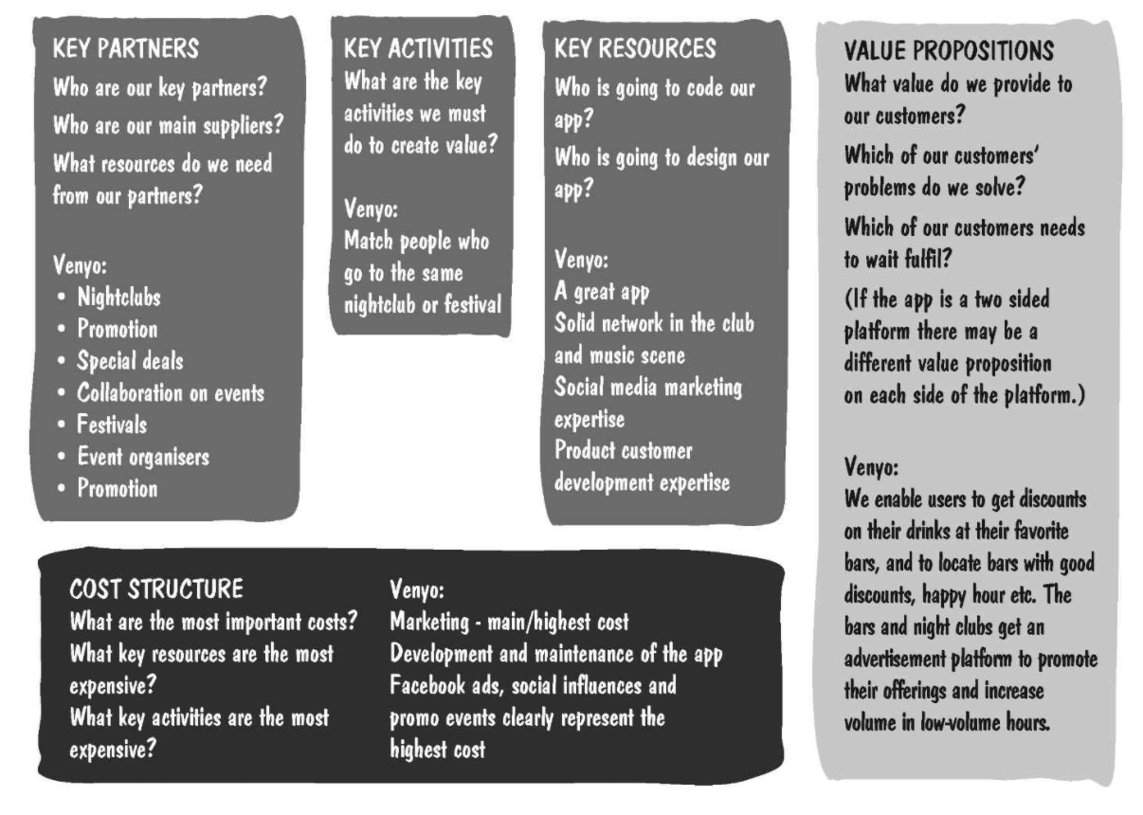
Figure 3.1 – Page 1 of 2 of the BMC template
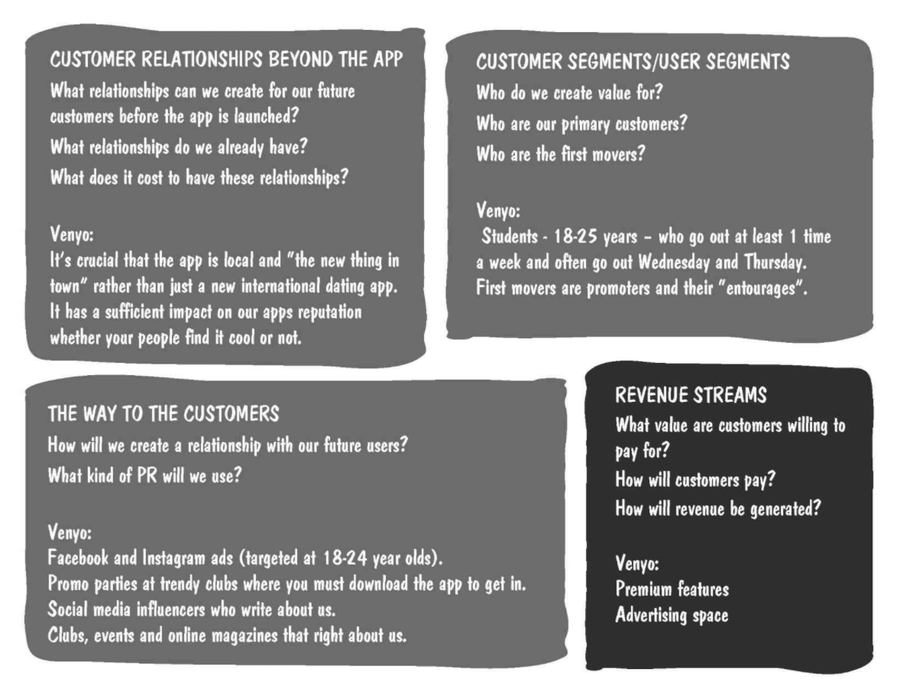
Figure 3.2 – BMC template page 2 of 2.

Instructions
Following the model shown in the textbook, create a one-page summary of the business plan for your mobile application design from Activities 1 and 2. Identify the key relationships, customers, and revenue streams related to your application. Although this is a short document, it summarizes many hours of planning.
- Customer and User Segments – Who is willing to pay you money for the service you provide?
- Value Proposition – What service do you provide to your customer, and why would they choose you over the competition?
- The Way to Customers – How will you reach your customers?
- Customer Relationships – How do you conduct business with your customer?
- Revenue Streams – How do you collect money? Are there multiple ways to earn revenue?
- Key Resources – What materials, services, or employees do you depend on to make your business run?
- Key Activities – What actions do you need to do on a regular basis to make the business succeed?
- Key Partners – Who supplies your product? Who works for you? Who sells your product?
- Cost Structure – What fixed costs are required to start up? What variable costs repeatedly occur?

Activity 3 Deliverables:

Submit a BMC of the business plan for your mobile application. Identify the key relationships, customers, and revenue streams related to your application.

